Prototype-CPL

|  |  |
| --- | --- |
| **Student Name/ID Number:** | Syukur Sidiq Nur Alam |
| **Academic Year:** |  |
| **Unit Assessor:** | **Arvinder** |
| **Project Title:** | CPL-Project prototype |
| **Issue Date:** | 07 – 09 - 2023 |
| **Submission Date:** | 07 – 09 - 2023 |
| **Internal Verifier Name:** |  |
| **Date:** | 07 – 09 - 2023 |

|  |
| --- |
| **Learner declaration** |
| I certify that the work submitted for this assignment is my own and research sources are fully acknowledged.  Student signature: Date: |

Login

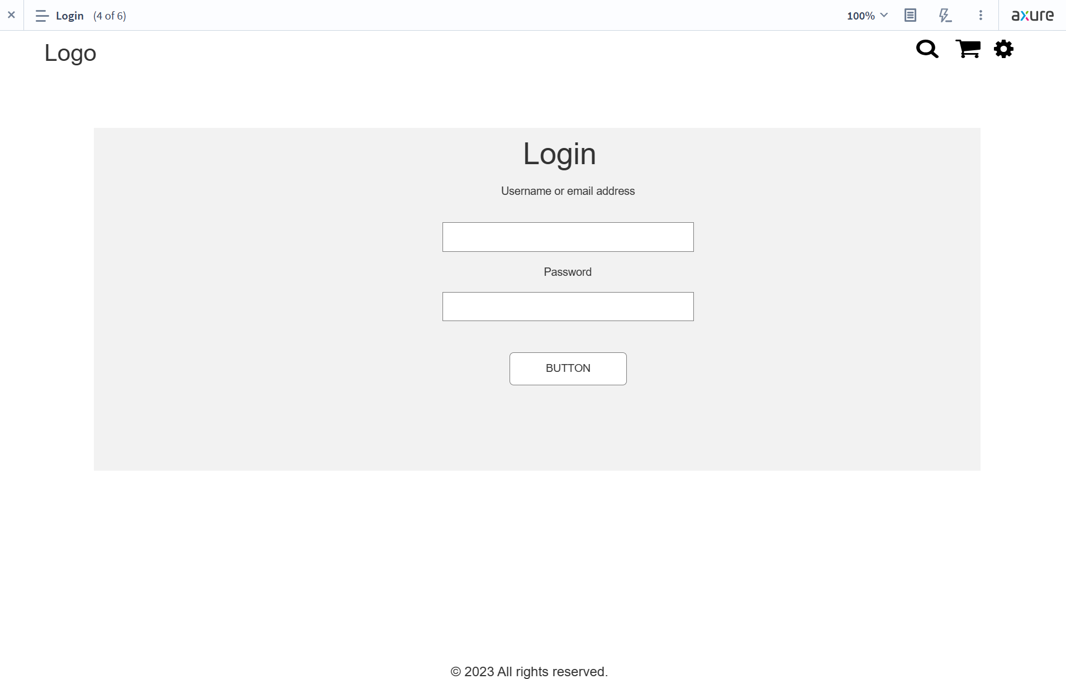

Registration

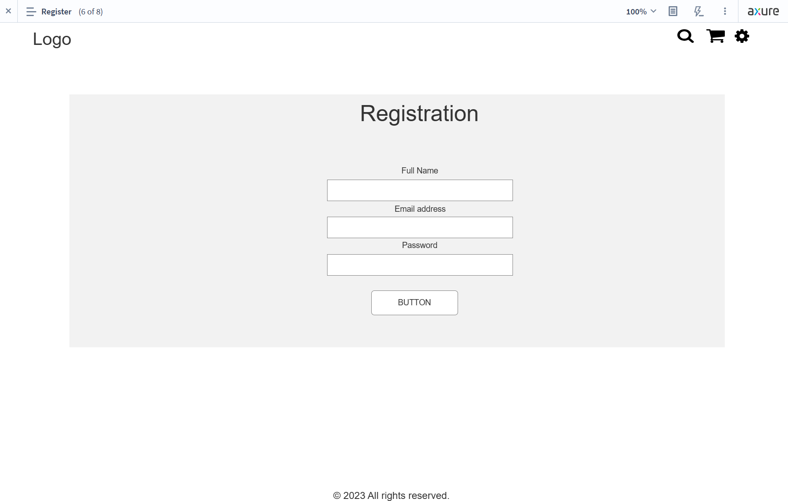

Dashboard

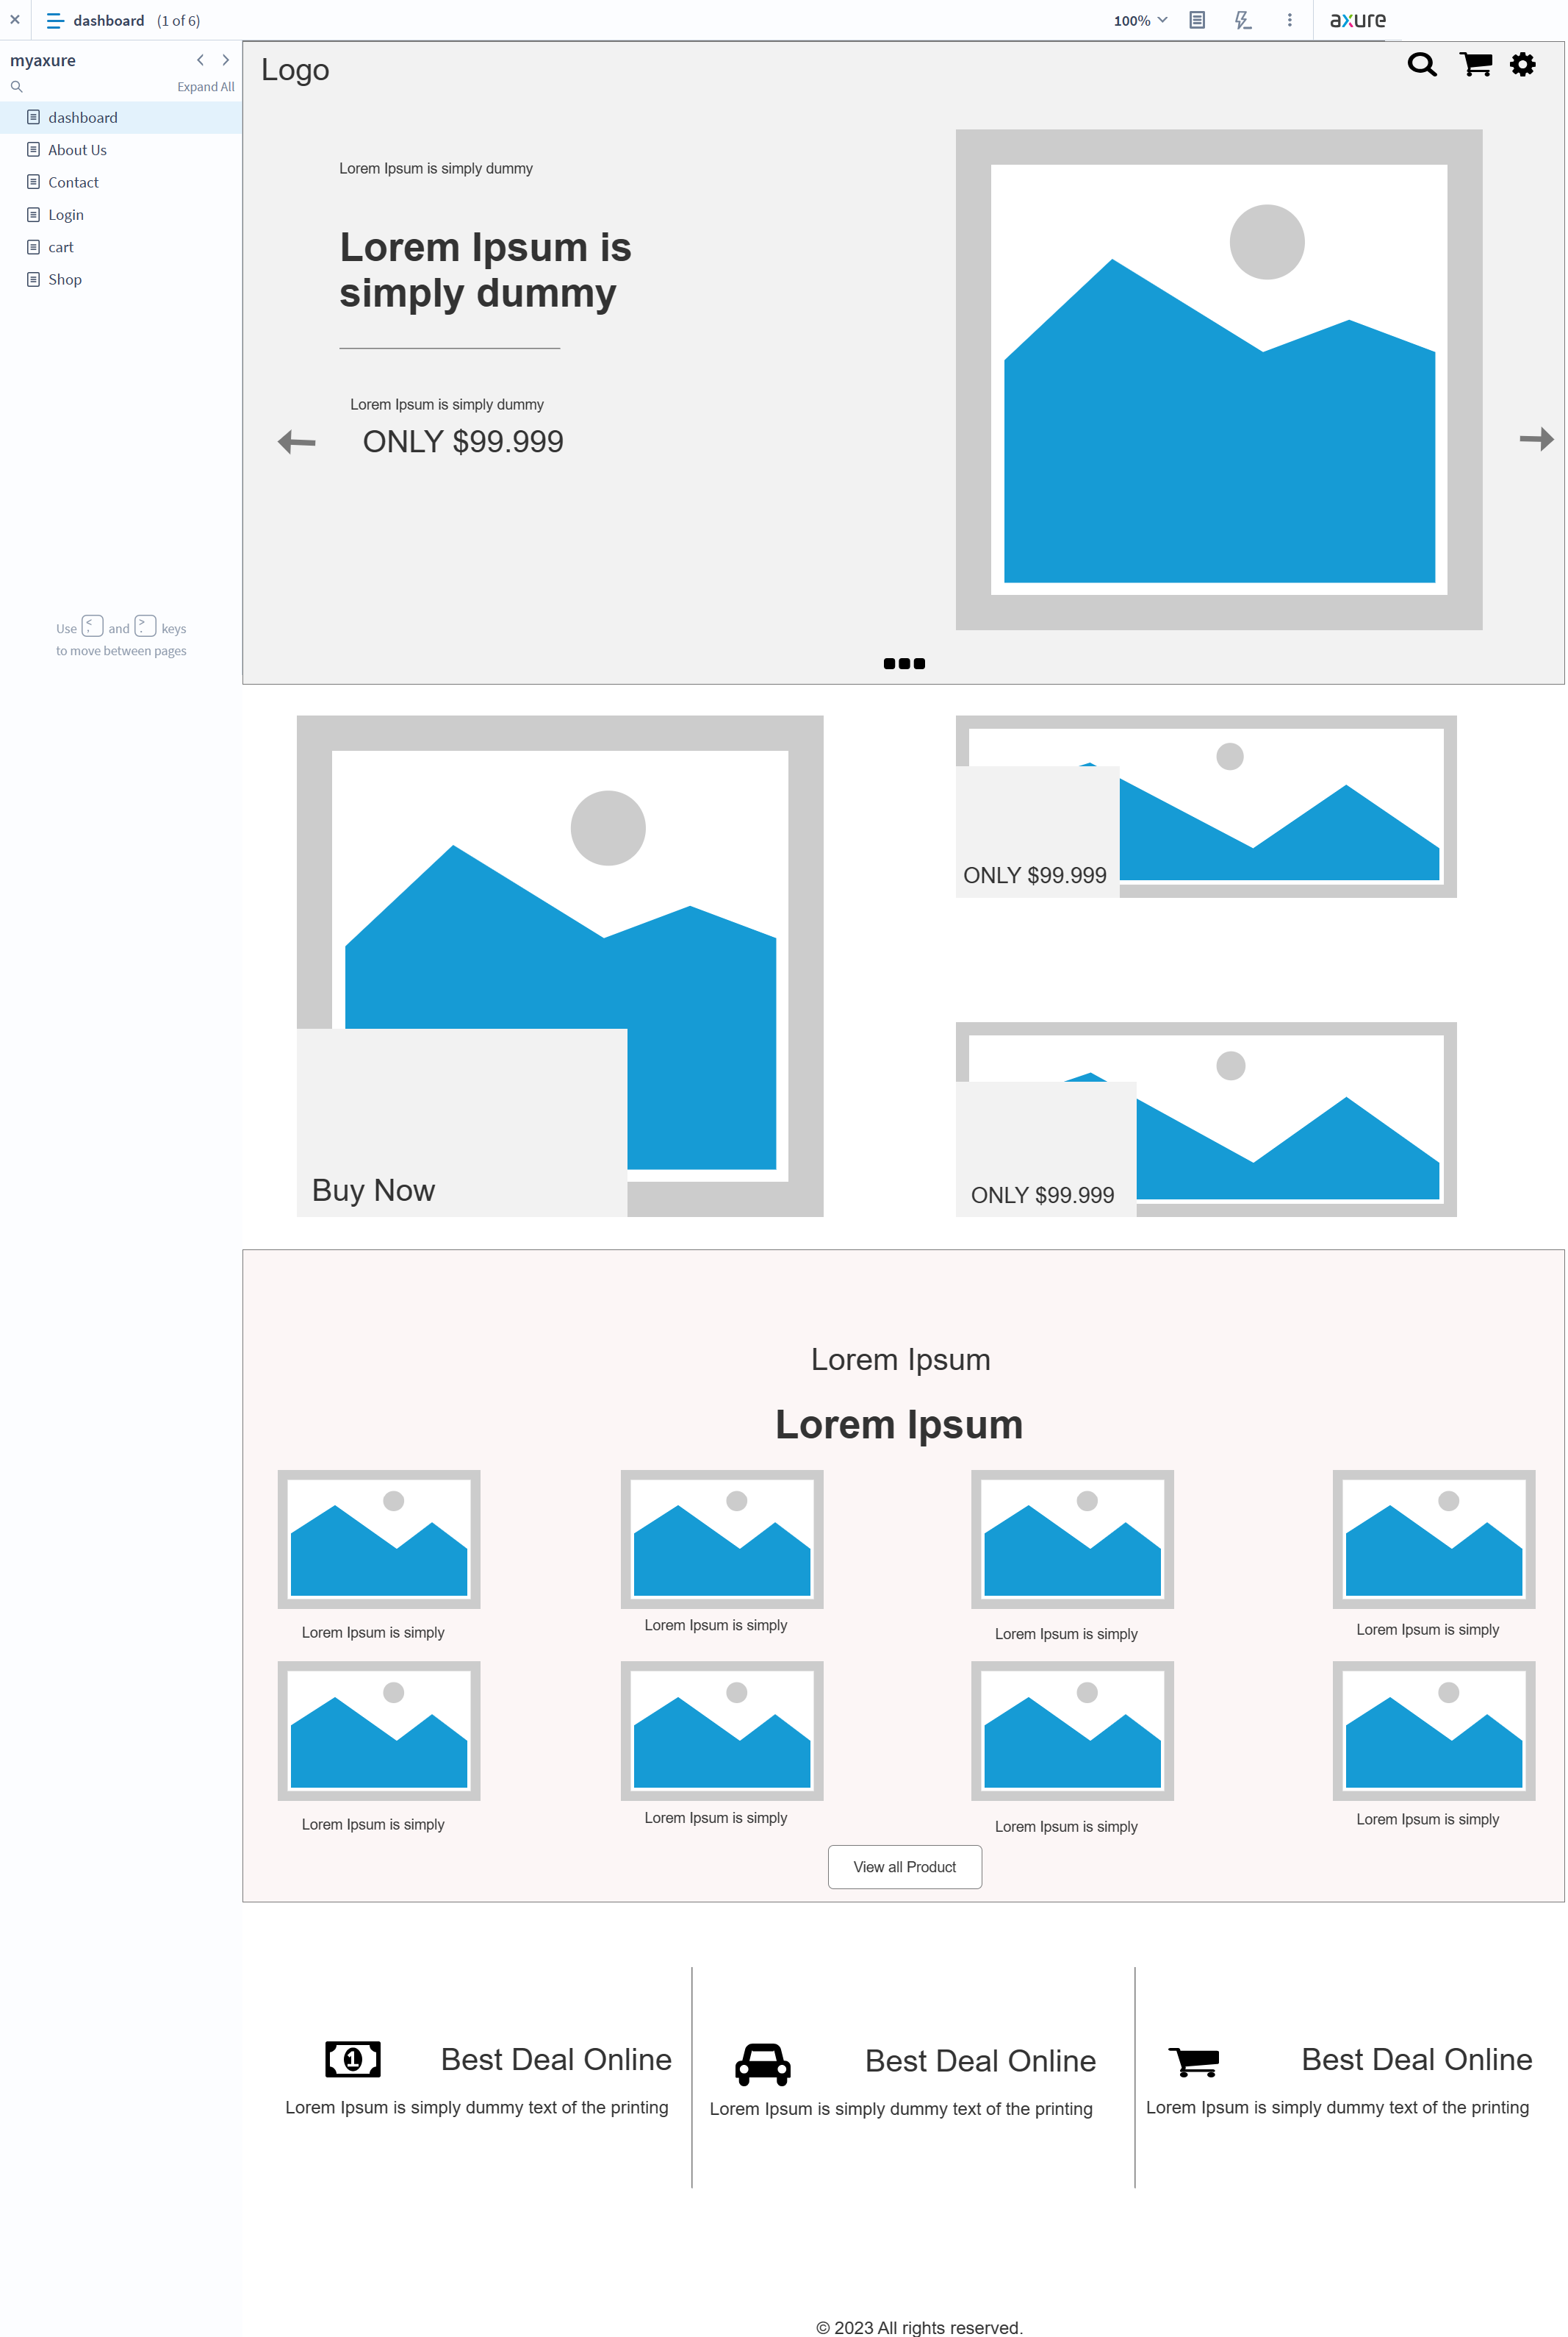

About Us

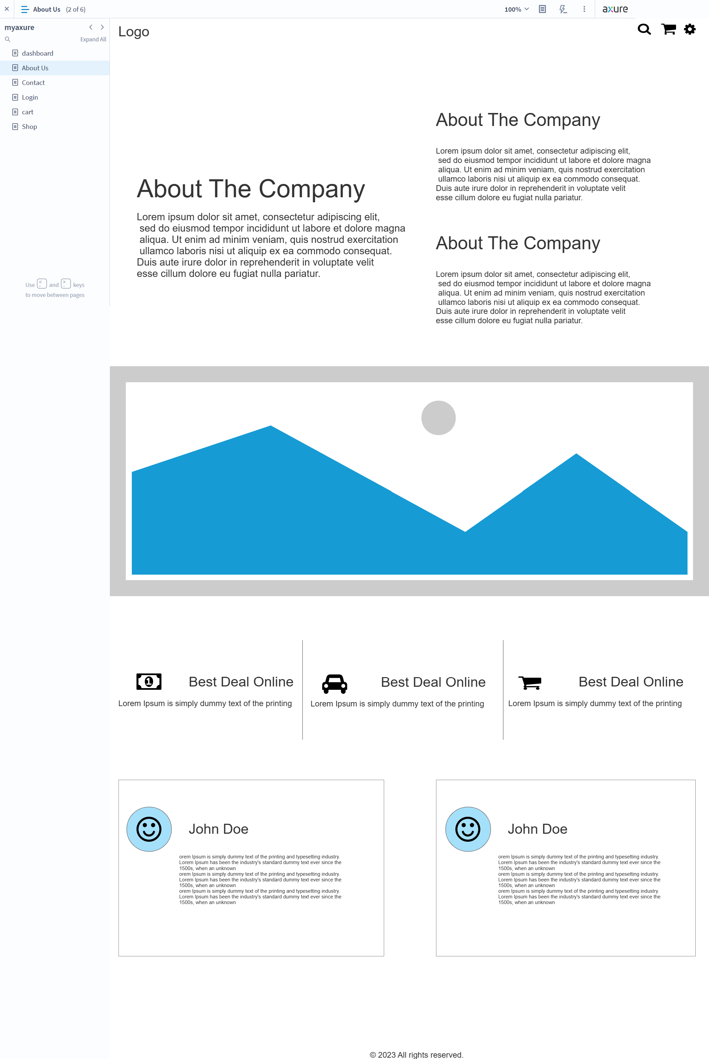

Contact us

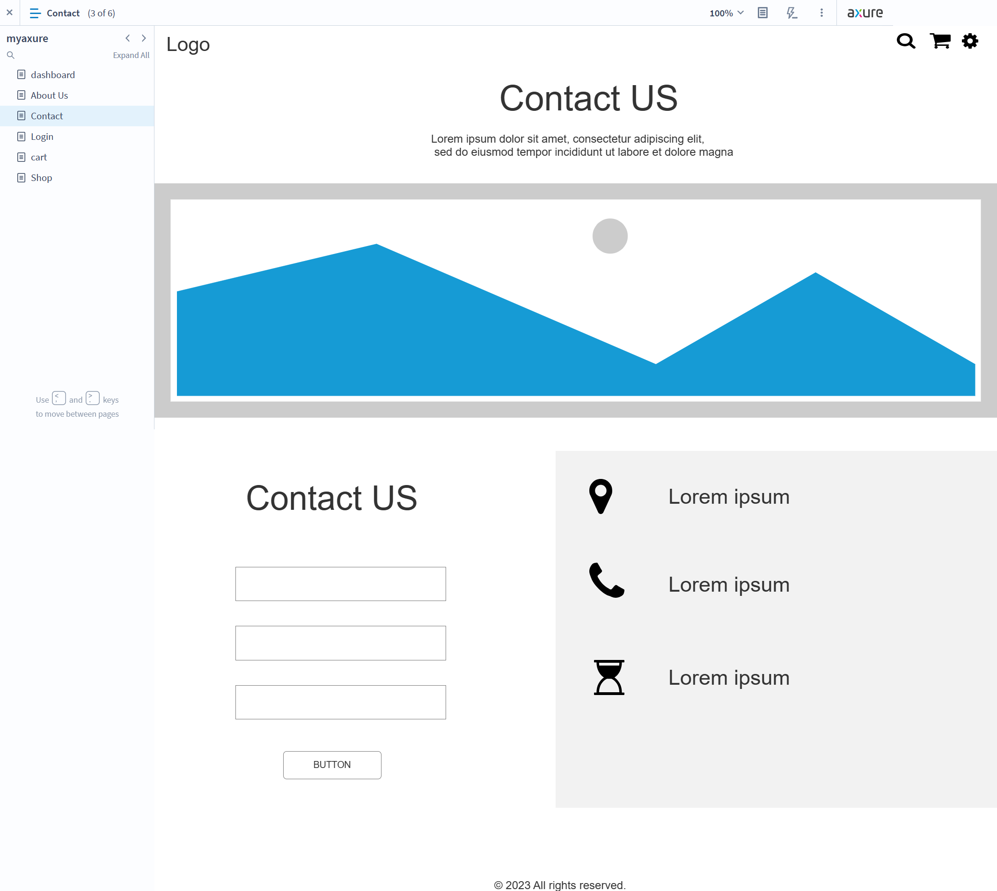

Cart

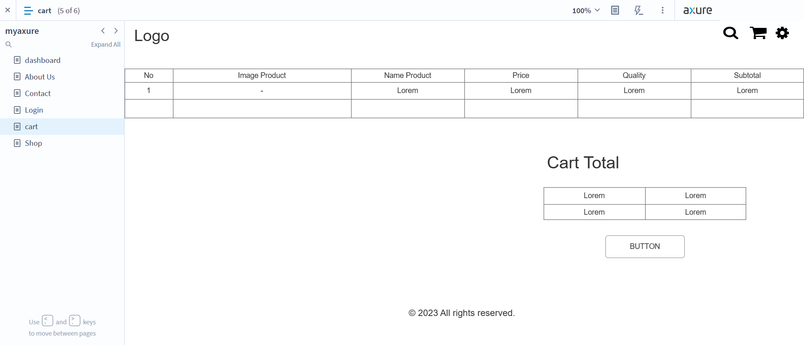

Shop

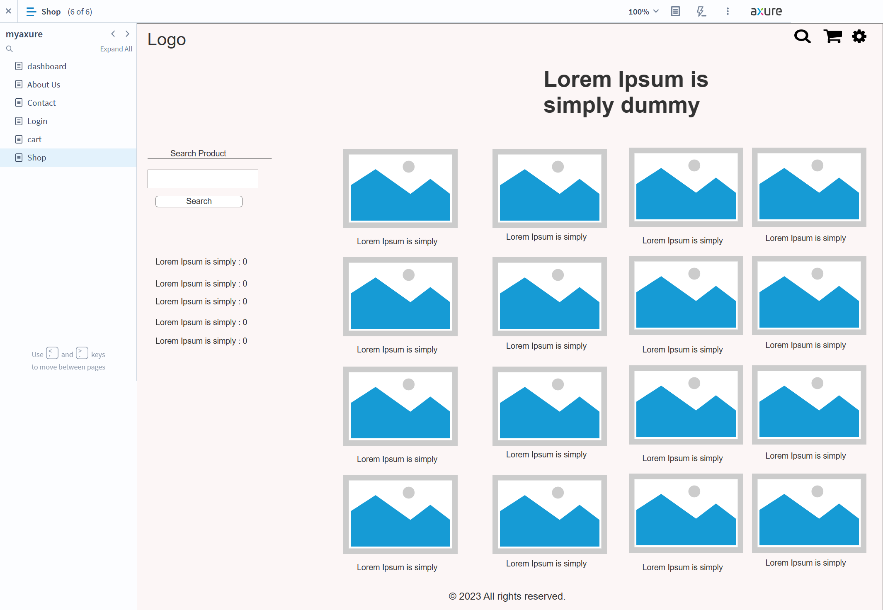

Detail Product

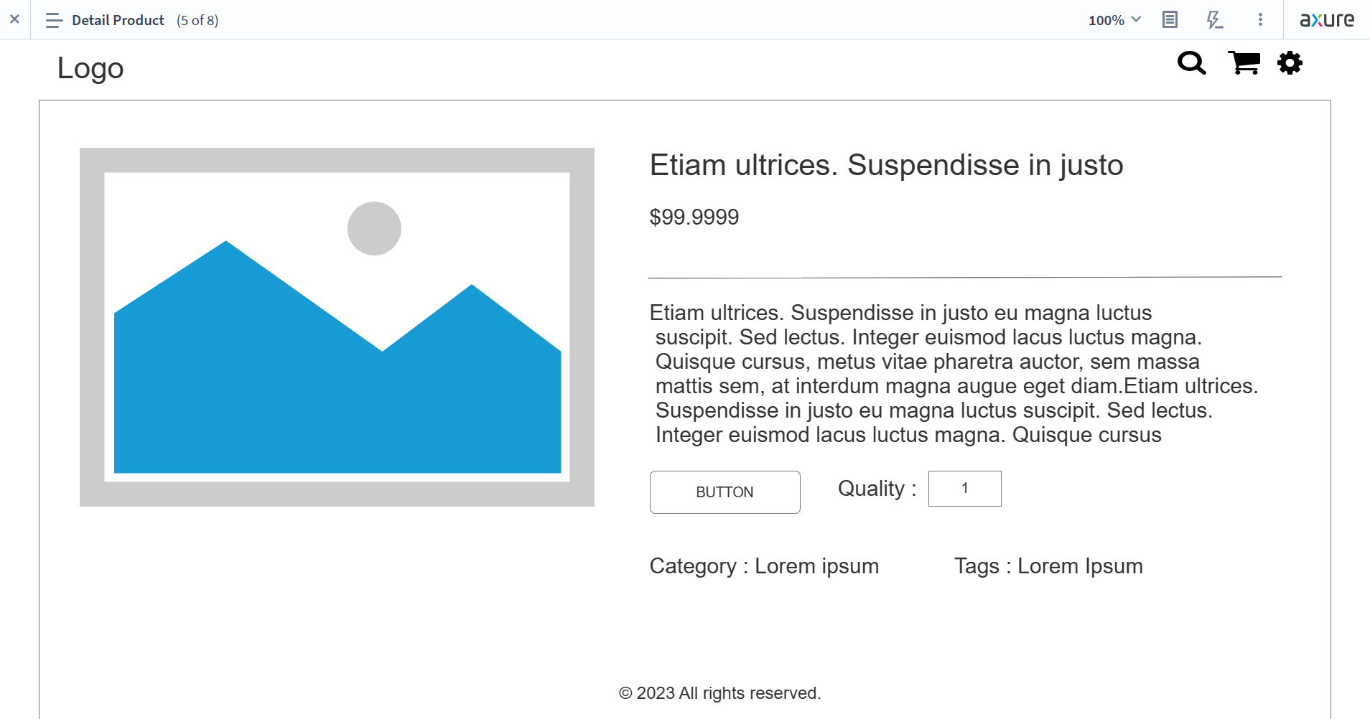

Profile Details

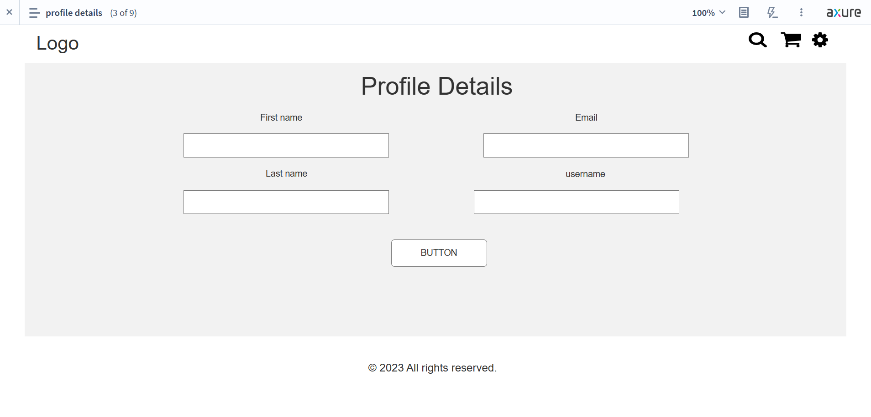

Admin Dashboard

